**GitHub Link**: <https://github.com/Unserved-sleep/Information-visualization-/tree/main/ParaView%20Assignment>

**2.  Apply the Contour, Slice, and Streamline filters to the dataset, adjust color maps, and submit screenshots with brief descriptions.**

**Surface Rendering**

Surface rendering is a technique used to visualize the outer surfaces of 3D objects in a dataset. It creates a solid-looking model by rendering only the outermost layer of the data, providing a realistic representation of the object's surface. This method emphasizes the external geometry of the data, making it appear as a solid object.

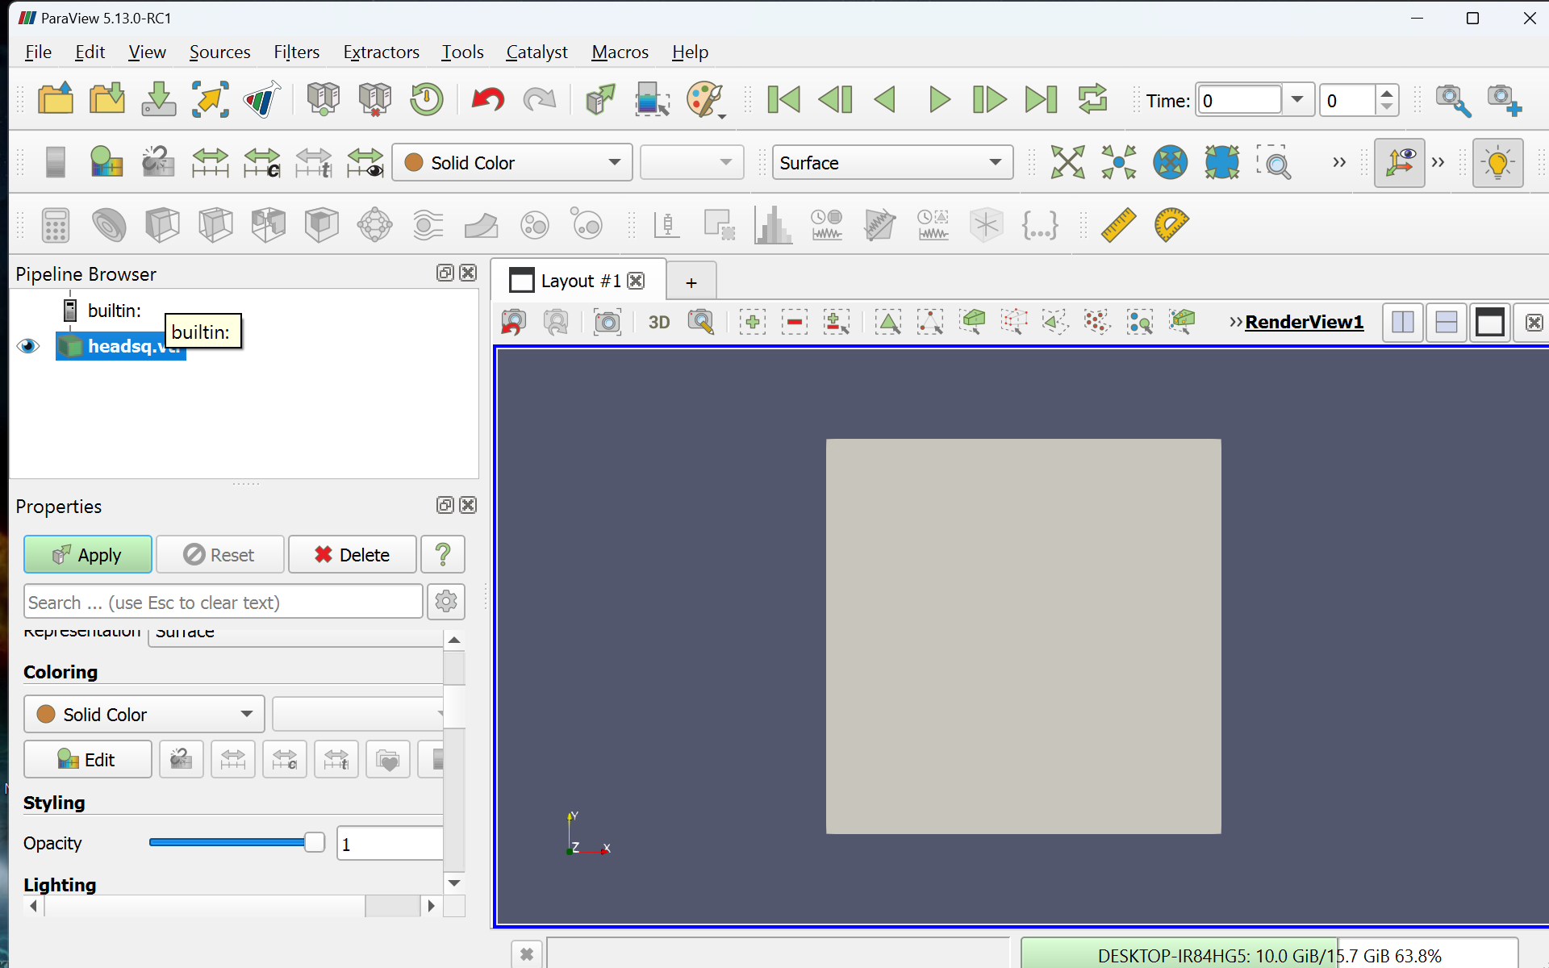

**Contour**

The contour filter, also known as isosurface extraction, generates surfaces that connect points of equal scalar value within a dataset. These surfaces, or "contours," represent specific levels of a variable (like pressure, temperature, or density) within the volume.

Contours are useful for identifying and visualizing specific features within a 3D dataset, such as the boundary of an object, or regions of interest that share the same value, like areas of high pressure in a fluid dynamics simulation.

**Value: 2075**

**Value: 1000**

**Slice**

The slice filter extracts a 2D cross-section from a 3D dataset by cutting through it along a specified plane (e.g., XY, XZ, or YZ). This slice provides a detailed view of the data values along that plane, converting a 3D representation into a 2D one.

Slices are valuable for analyzing specific sections of the data, allowing you to examine variations across a single plane and understand the internal structure of the dataset. It’s widely used in medical imaging and engineering to study layers or sections within a 3D volume.

**Center**

**Inside**

**Streamline Filter**

The streamline filter visualizes flow data by tracing paths, or streamlines, through a vector field (a field that assigns a vector to every point, like fluid flow or wind direction). These streamlines represent the trajectories that particles would follow if placed in the flow, illustrating the direction and speed of the flow at different points.

Streamlines are essential in fluid dynamics and meteorology to understand and visualize the flow patterns of liquids, gases, or other vector fields, helping to identify vortices, flow separations, and other critical flow characteristics.